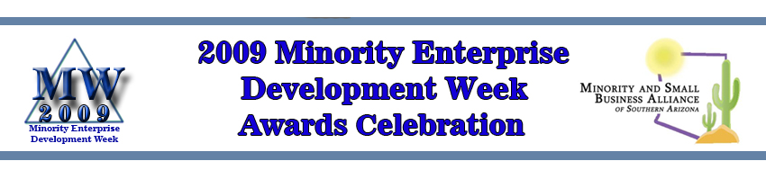2009 MED WEEK SPONSOR RSVP FORM
Contact Name:

Company Name:

Sponsorship Level: (Circle One) Platinum Gold Silver Advocate Friendship
10 Tickets 8 Tickets 6 Tickets 4 Tickets 2 Tickets

Phone Number:

Fax Number:

Address:

City, State, & Zip:

E-Mail Address:

Entrée Selection: Chicken No.
Beef: No.
Special Diet (Specify) No.

Please list attendees
Name:

Name:

Name:

Name:

Name:

Name:

Name:

Name:

Name:

Name:

Signature:

Please make checks payable to:
Minority and Small Business Alliance
and mail to:
Minority and Small Business Alliance
Attention: MED Week Registrations
PO Box 766
Cortaro, AZ 85652-0766

